Practitioner’s name
Practitioners nominals

Dietary analysis – eat well through knowledge
  - [Select Date]
Created by Dr. Rodney Lopez for Activ8Health Clients and accredited Practitioners: Copyright © Dr Rodney Lopez 2018. All Rights Reserved
Customer Name
DOB
Email
Mobile
Landline (include area code)
Practitioner’s Email

Comment on medications or medical concerns
Comments to the Dietitian



Choose one of two options
Option 1: Download the Smartphone Easy Diet Diary App
This App has been designed to work with Foodworks® a professional nutrition analysis software program . It has a vast database of Australian products. It allows you to record food intake and exercise. It also has barcode scanning features for easy data input. Simply email your results to the Dietitian
Option 2: Hardcopy, print > manually input data > mail or send digitally (scan or take a photo)
Paper-based tracking of food intake, quantities, brands, and symptoms.

Payment
Payment will be required first through the www.a8h.com.au portal before proceeding. No payment outside this web portal will be sanctioned or supported by this website. Your practitioner can place this service in your Activ8Health cart for approval, registration then processing. Registration simply allows you to review and agree to the terms and conditions before proceeding

Analysis begins
Dietary analysis will begin once the dietary data is received. Allow for 2 weeks for analysis and reporting
Analysis completed – what now?
A report will be emailed to you. It is a stipulation of this website that all reporting and feedback be discussed with your doctor or specialist before implementation of any changes to dietary management

Using the Easy Diet Diary App

- Download the App on your Smartphone
- Touch the '+' symbol as highlighted below
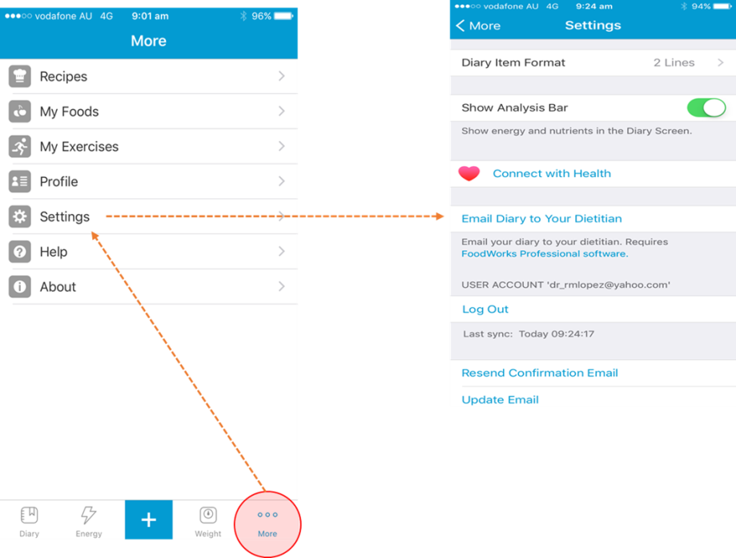
- Select Breakfast, Lunch, Dinner or Snacks
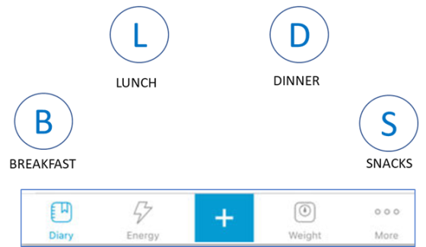
- Choose a food or use the Smartphone camera to scan a barcode (to the right of 'Find a food' search bar)
- Simply add foods as you eat or take a picture of your meal or snack and enter the details later
- Finish a 3-day diet diary or more if you feel you need to.
- If you have the same thing day-in and day-out, only one day’s dietary data is required
- You can email your diary to the Dietitian --- just go to 'More' on the bottom left, then 'Settings' and then 'Email diary to Your Dietitian'

Choose an item.

Choose an item.

Choose an item.

Choose an item.

Alcohol: Days per week _____
Number of standard* drinks per week: ______
(* 100 ml of wine or 1 middy of beer or 1 nip of spirits = 1 Standard Drink)

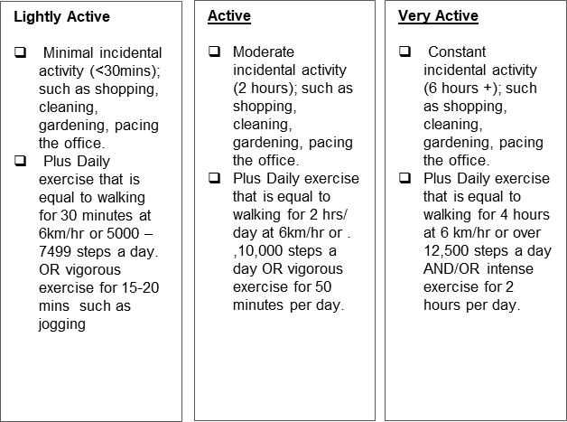

Comments about dietary habits, dietary sensitivities, dietary concern/s, goals

3 to 7 Day Dietary Analysis

Food/Brand | Amount | Time Eaten | Any symptoms after eating? | In company? | Activity while eating | Mood
e.g Up-&-Go | 250 ml | 7am | Bloating | Alone | Driving | Stressed
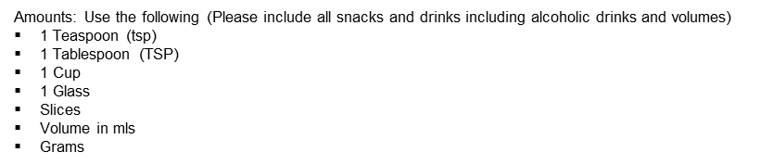

3 to 7 Day Dietary Analysis

Food/Brand | Amount | Time Eaten | Any symptoms after eating? | In company? | Activity while eating | Mood
e.g Up-&-Go | 250 ml | 7am | Bloating | Alone | Driving | Stressed

3 to 7 Day Dietary Analysis

Food/Brand | Amount | Time Eaten | Any symptoms after eating? | In company? | Activity while eating | Mood
e.g Up-&-Go | 250 ml | 7am | Bloating | Alone | Driving | Stressed

3 to 7 Day Dietary Analysis

Food/Brand | Amount | Time Eaten | Any symptoms after eating? | In company? | Activity while eating | Mood
e.g Up-&-Go | 250 ml | 7am | Bloating | Alone | Driving | Stressed

3 to 7 Day Dietary Analysis

Food/Brand | Amount | Time Eaten | Any symptoms after eating? | In company? | Activity while eating | Mood
e.g Up-&-Go | 250 ml | 7am | Bloating | Alone | Driving | Stressed

3 to 7 Day Dietary Analysis

Food/Brand | Amount | Time Eaten | Any symptoms after eating? | In company? | Activity while eating | Mood
e.g Up-&-Go | 250 ml | 7am | Bloating | Alone | Driving | Stressed

3 to 7 Day Dietary Analysis

Food/Brand | Amount | Time Eaten | Any symptoms after eating? | In company? | Activity while eating | Mood
e.g Up-&-Go | 250 ml | 7am | Bloating | Alone | Driving | Stressed

Terms for this service
Please note that this analysis and report takes time and effort and the practitioner's report will include a maximum of 3 post-report email exchanges to discuss any queries you have. Ongoing discussion will require time package purchases. The minimum time package purchase is 15 minutes with other packages that include 30, 45 and 60 minutes increments. These packages are purchased upfront and as a whole with no refunds if your queries have been dealt with. Each 15 minute increment will allow for 1 – 2 queries only. Your Dietitian can guide you with regard to how long a query may take as this may need to be researched to provide you with an informed response.
Approved by:
For <Client’s Company> |  |  | Date |  | For Practitioner’s name |  |  | Date

