Activ8health
VERSION-2 21-10-2021

holman LIPID test results & feedback
  - Created by Dr Rodney Lopez MBBS (USyd) GradCertNutriMed (RMIT for the Activ8Health Network
Client Name
DOB
Report Date | - [Select Date]
Practitioner’s Name
Important: This information is general in nature and acts as a guide only. It is not intended to be interpreted as providing advice on treatment. All information should be discussed with your medical practitioner or treating specialist as appropriate. It is vital that information is placed into your specific clinical context for informed decision making by medically trained personnel. The practitioners are qualified Dietitians and as such can provide information on dietary approaches, not medical treatment/s. So please ensure you discuss all information you get with your medical practitioner/s before adopting any dietary or medication intervention/s or change. The final report you receive will need to be interpreted by your designated medical practitioner. Each practitioner works independently on this website. Queries about feedback regarding dietary services, tests or products should always be directed to the practitioner involved in your care.

If you are not a client of Activ8Health and did not receive this report through the www.a8h.com.au by an authoriSed Activ8Health practitioner, you may not be getting the advice you deserve. If any practitioner is not an authoriSed Activ8Health practitioner providing you with this report, please send a message to admin@a8h.com.au

Inflammation parameters & potential:

Your result | Level | Comment
Omega-3 Index | Choose an item. | The Omega-3 index is the combined value of two of the major omega-3 components (DHA & EPA).  The Omega-3 index is determined from your blood composition as a percentage. If your percentage is for example 5%, then 5% of your total blood fatty acids are indeed omega-3's  "A high fish intake and/or an Omega-3 Index ≥8% is  associated with a very low risk of sudden cardiac death,  compared to those with low or no fish intake or an  Omega-3 Index of ≤4%³."
% Omega-3 HUFA | Choose an item. | HUFA = Highly Unsaturated Fatty Acid  Omega-3's have numerous double bonds, and these are called unsaturated bonds  The amount of omega-3's will determine how well you will dampen inflammatory responses. These Omega-3's are vital to good health
% Omega-6 HUFA | Choose an item. | There is an abundance of Omega-6's in Western diets through processed foods using cheap Omega-6 rich oils. Omega-6's and Omega-3's compete for the same enzymes (see graphic below), and so if you have more Omega-6's, the pathway will be driven towards inflammatory eicosanoids. These same compounds are the ones that anti-inflammatory medications' attack' to lower fever or decrease pain through inflammatory processes. Keeping Omega-6's at optimal intakes (not high) is vital to good health. Keeping Omega-6's at a lower intake will limit inflammation in the body.
Omega-6 to Omega-3 Ratio | Choose an item. | The Omega-6 to Omega-3 ratio is a vital marker for inflammation potential in the body (Simopoulos 2002)  Ideally, this ratio should be less than 4:1, meaning less than 4 molecules of Omega-6 to 1 Omega-3 molecule. Omega-6 essential polyunsaturated fats (PUFAs) produce the Series 2 & 4 Eicosanoids that are inflammatory. Therefore, when you use an anti-inflammatory from a Pharmacy, you are often targeting these compounds derived from Omega-6 fatty acids as mentioned above.  Western populations may have 10 – 15 times more Omega-6's in their diet from processed foods using cheap vegetable oils high in Linoleic Acid (LA) and worsened by not consuming enough Omega-3 essential fatty acids as many people avoid fatty fish like Salmon, Trout, Herring, Sardines or Mackerel.  Omega-3 intake should include the short-chain Alpha-Linolenic Acid (ALA) rich in Flaxseed and should also have Gamma-Linolenic Acid (GLA) from Evening Primrose Oil (EPO) or Borage Oil. GLA may be on the Omega-6 side but produce anti-inflammatory compounds.  Not all the Omega-6's are bad, just the highly processed and damaged forms of Omega-6. We are not trying to eliminate Omega-6's because their inflammation helps the immune system fight off infections and other threats.  So, don't try to saturate your body with Omega-3's but aim for a good balance. Your practitioner can guide you if you would like further information. They can advise you on fees involved for their time, effort, and knowledge to assist you towards healthy outcomes through dietary management.
AA/EPA Ratio | Choose an item. | Why choose these molecules to measure? These are very important markers as they lead to the production of both inflammatory molecules from Arachidonic Acid (AA) or anti-inflammatory markers from Eicosapentaenoic Acid (EPA). Arachidonic Acid is the master molecule from which all the Series-2 and Series-4 inflammatory eicosanoids occur, and these molecules derived from Arachidonic Acid are the reason you use an anti-inflammatory like Ibuprofen from across the counter at the chemist to offset these inflammatory molecules derived from Arachidonic Acid. A high level of Series-2 and 4 inflammatory eicosanoids affect a multitude of chronic diseases.  Eicosapentaenoic Acid (EPA), on the other hand, is the vital precursor molecule from which Series-3 and Series-5 anti-inflammatory molecules arise. These anti-inflammatory molecules offset the inflammatory molecules derived from AA.  Anyone with a chronic illness has a high risk of inflammation driving their disease states, and markers like C-Reactive Protein (CRP), and inflammatory cytokines (different to the eicosanoids) are often elevated.  Not consuming enough Omega-3's will mean runaway inflammatory processes, especially if that individual is consuming a typical Western diet leading to more pain in the joints, muscles, damage to organ systems, including the brain, and inflammation can potentially drive many cancers.

the omega-3 family of molecules: your levels

Your result | Level | Comment
Knowing about your personal Omega-3 levels enables you to take dietary action
ALA | Choose an item. | ALA stands for Alpha-Linolenic Acid, a short-chain Omega-3 that is found in high amounts in Flaxseed and Chia, and Hemp seeds.  ALA like LA (Linoleic Acid) are two Essential Fatty Acids – i.e. your body cannot synthesise these molecules. These have to come from your diet. Marine algae can efficiently convert ALA into the longer change polyunsaturated DHA and EPA. Fish eat these algae and then incorporate and concentrate these vital fatty acids in their flesh. As long you consume wild fatty fish (not farmed fish fed grains), you will benefit from these fatty acids. Salmon, Herring, Mackerel, Sardines and Trout are good sources.  In typical Western diets, this important ALA molecule is consumed in low quantities, and ALA was thought to play an important role in the Lyon Diet Heart Study analysis (The Mediterranean Diet)  The purpose of this analysis is to find deficiencies and use dietary management to fine-tune low results for any of the Omega-3 family of molecules. This process is Precision Nutrition in action!
EPA | Choose an item. | Eicosapentaenoic Acid (EPA) – found in high amounts in fish oil and certain algae. Important for the Series-3 and 5 eicosanoids discussed above. EPA-rich supplements are thought to offer a greater impact on depression symptoms.
DPA | Choose an item. | DPA is an elongated metabolite of EPA and a molecule intermediate between EPA and DHA (Kaur et al., 2011).  DPA is taken up by the lining of the blood vessels (the endothelium) 10x more so than EPA. (Kaur et al. 2011)  DPA is vital to form Specialised Proresolving Mediators (SPM's) – they resolve inflammation, and these include 7 Resolvins, 2 Protectins and 3 Maresins.  More and more scientific research is focusing on DPA as a wonderful anti-inflammatory Omega-3 and the positive effect this has on cardiovascular health. Unfortunately, the Cochrane review found no benefit of Omega-3's on cardiovascular disease. Often nutrition research can miss the mark by not studying the right molecule in the right concentrations needed for benefit.
DHA |  | Docosahexaenoic Acid – This is a vital structural component of the Brain, Spinal Cord, Retina and Skin. DHA can make up 40% of the polyunsaturated fatty acids (PUFAs) of the brain and up to 60% of the retina. DHA can be converted to its own Specialised Proresolving Mediator (DHA derived SPM)
OxLDL (Oxidized-LDL) | Choose an item. | Oxidized-LDL is damaged LDL through free radicals or reactive oxygen species created in the body by bad diets or consuming way too much food. Of interest is that egg yolks increase LDL by 10% but even more important is that egg yolks can increase Oxidized-LDL by 34 (Spence 2002).  Once again, keeping oxidative stress low through practitioner-guided intraday fasting, practitioner-guided diets high in the right fats, high in phytochemicals and nutrient density without the free-radical generating calories is highly protective of your blood vessels, especially if you have a strong family history of cardiovascular disease or have suffered a heart attack, stroke or have peripheral vascular disease.

the omega-6 family of molecules: your levels
Your result | Level | Comment
Knowing about your Omega-6 levels enables you to take dietary action
Total Omega-6 Score | Choose an item. | You are now aware that the Omega-6 level indicates your propensity for inflammation. We don't want this level high, and the only way to prevent this is through diet.
LA | Choose an item. | Linoleic Acid (LA) an essential fatty acid, needs to be acquired through the diet. This molecule is the major precursor for all the inflammatory molecules, such as Arachidonic Acid (AA). LA is rich in vegetable oils, and thus processed foods using cheap vegetable oils will be rich in LA, pushing you towards an inflammatory ratio of AA to EPA.  For anyone with a chronic illness, many of which are driven by inflammatory processes, keeping the LA to an optimal level may significantly improve health outcomes.
DGLA | Choose an item. | Dihomo-γ-linolenic Acid (DGLA) is a beneficial compound even though it is in the Omega-6 category, and so you want higher levels of this compound. It produces Series-1 compounds that are anti-inflammatory.  DGLA compounds can block the effect of Arachidonic Acid (AA)
AA | Choose an item. | AA or Arachidonic Acid from the information above is the parent compound for the inflammatory Series-2 & 4 eicosanoids. We want to keep all of these inflammatory Omega-6 compounds in check.

oxidised LDL (Ox-LDL) levels – The importance of this compound
Your result | Level | Comment
Knowing about your personal Oxidized-LDL level enables you to take dietary action
OxLDL (Oxidized-LDL)  This item may not be a part of the standard omega-3 testing | Choose an item. | Oxidized-LDL damages LDL through free radicals or reactive oxygen species created in the body by bad diets or consuming too much food.  Of interest is that egg yolks increase LDL by 10% but even more important is that egg yolks can increase Oxidized-LDL by 34% (Spence 2002).  Once again, keeping oxidative stress low through practitioner-guided intraday fasting, practitioner-guided diets high in the right fats, high in phytochemicals and nutrient density without the free-radical generating calories is highly protective of your blood vessels, especially if you have a strong family history of cardiovascular disease or have suffered a heart attack, stroke or have peripheral vascular disease.

Why the fuss about the Omega-6 to Omega-3 ratio?
These two pathways are fundamental regarding the balance between the anti-inflammatory Omega-3 pathway and the inflammatory Omega-6 pathway. Both these pathways compete for the same enzymes, so if you consume more Omega-6's, the more Arachidonic Acid (AA) you will create and the more inflammatory Series-2 & 4 Eicosanoids are formed. These are the same inflammatory eicosanoids that create fevers, pain or joint inflammation. Anti-inflammatory medications such as Ibuprofen dampen these inflammatory molecules.
Concerning Omega-3's, the Eicosapentaenoic Acid (EPA) component produces the anti-inflammatory Series 3 & 5 eicosanoids.
GLA/DGLA are products of the Omega-6 pathway but are anti-inflammatory.
It is essential to get a broad spectrum of essential fatty acids, including GLA (Evening Primrose Oil (EPO) or Borage Oil). It is not the aim to overwhelm the Omega-6 pathway with a large intake of Omega-3's as this will impair the immune system that uses the Omega-6 pathway to mount an attack on bacteria, viruses or cancers through the inflammatory eicosanoids generated by this pathway. Instead, we want a ratio below 4:1 of Omega-6's to Omega-3's, and this can be tested regularly to find that 'sweet spot' of balance.

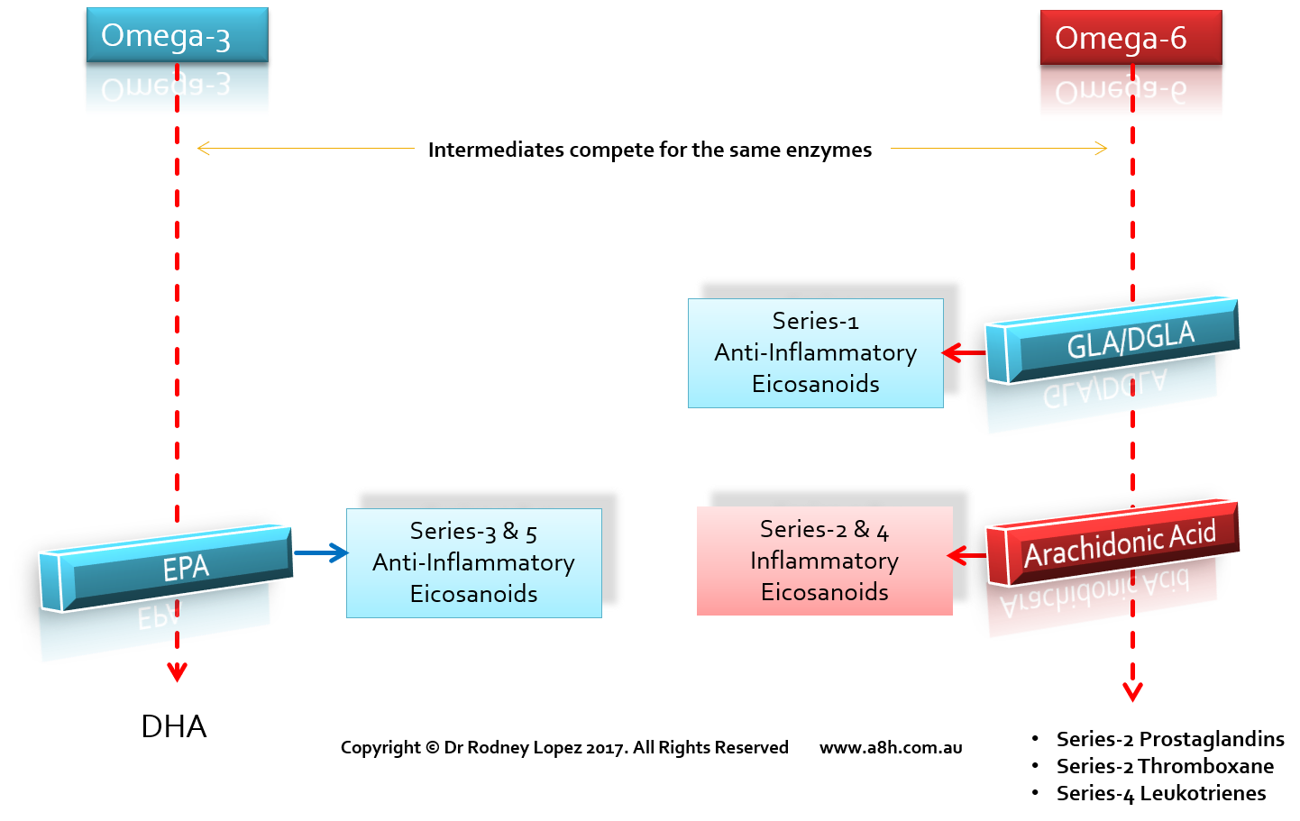

Other comments:

References
- Kaur, G., Cameron-Smith, D., Garg, M. and Sinclair, A.J., 2011. Docosapentaenoic acid (22: 5n-3): a review of its biological effects. Progress in lipid research, 50(1), pp.28-34.
- Spence, J. D. (2002). "Importance of diet in vascular prevention: vastly underestimated." Circulation 106(18): e133-e133.
- Colquhoun, D. (November 01, 2018). "Omega-3 Marine Polyunsaturated Fatty Acids Post-myocardial Infarction." (31, Expert Monograph). https://www.healthed.com.au/monographs/omega-3-marine-polyunsaturated-fatty-acids-post-myocardial-infarction/

