Activ8Health dietary guidelines

VERSION 2 21-10-2021
Client Name
DOB
Report Date | - [Select Date]
Practitioner’s Name



Please note a quickstart guideline exists and your practitioner can guide you one-on-one over the internet AT A VERY REASONABLE PRACTITIONER SUPPORT COST. THIS INCLUDES A FULL SHOPPING GUIDE AS WELL. THIS CAN TAKE ONLY ½ HOUR, AND YOU WILL HAVE ONGOING ACCESS FREE OF CHARGE THROUGH YOUR LOGIN AT WWW.A8H.COM.AU

CHRONONUTRITION
This is a critical part of eating. Knowing when to eat during a day is one of the most crucial aspects of your response to the foods you eat. Chrononutrition is the study of food timing, and the science dates back to the 1970s and subsequent research on shift workers who suffer from many chronic diseases due to the erratic intake of food.
Please ask your practitioner to guide you through the Quick Start Special Access diet
A Practitioner Support Package will apply if you want to know more about this important concept

the plan-a personalised dietary plan
- LOW STARCHY-CARB DIET – High in vegetable carbs and some fruit carbs
- FOR FAT LOSS
- TO STAY LEAN
- A HIGH FIBRE DIET
- HIGH IN PHYTOCHEMICALS AND ANTIOXIDANTS
- CAN BE PURELY PLANT-BASED BY CHOOSING THE RIGHT PROTEIN SOURCES (OPTIONS GIVEN) – Those on vegan diets should consider a professional multivitamin and mineral supplement and a professional omega-3 combination of DHA/Choline/EPA/GLA

Important: This information is general and acts as a guide only. Information on this website should not be interpreted as providing advice on treatment. Any information should be discussed with your medical practitioner or treating specialist as appropriate. Information must be placed into your specific clinical context for informed decision making by medically trained personnel. The practitioners are qualified Dietitians and as such, can provide information on dietary approaches, not medical treatment/s. So please ensure you discuss all information you get with your medical practitioner/s before adopting any dietary or supplement intervention. The final report you receive will need to be interpreted by your designated medical practitioner. Each practitioner works independently on this website. Queries about feedback regarding dietary services, tests or products should always be directed to the practitioner involved in your care. If you are not a client of Activ8Health and did not receive this report through the www.a8h.com.au by an authorised Activ8Health practitioner, you may not be getting the advice you deserve. If any practitioner is not an authorised Activ8Health practitioner providing you with this report, please send a message to admin@a8h.com.au

Why use this dietary plan?
This dietary plan is a Plant-Based or Plant-Forward type of diet. Such a diet is regarded as one of the best strategies you can use for a multitude of reasons to avoid chronic diseases and to stay lean and healthy. A formidable wealth of research backs the reason to recommend such a diet.
The Plant-Forward diet emphasises but is not limited to, plant-based eating with a view to an optimal intake of nutrients, sustainability, environmental stewardship and social responsibility. This style of eating was proposed by Harvard University’s T.H. Chan School of Public Health, and this makes sense.
Dietary advice needs to move way beyond seeing food as calories or energy as this is now an outdated mode of thinking. Food can have profound health impacts in many ways, and this knowledge needs to be incorporated into the thoughts of the public who should be encouraged to be mindful of food and the adverse impact it has on the body meal-by-meal and to see diet-as-medicine. This diet aims to avoid adverse postprandial (after-eating) meal effects such as blood glucose and triglyceride (fat) surges and the longer-term dietary impacts on cells, tissues and organ systems, including the gut microbiome. This diet optimises fibre, nutrient, antioxidant and phytochemical intake to ensure your body is well nourished and that your cellular machinery has all the micronutrients required for efficient biochemical reactions and molecular functioning. There is a focus on the gut microbiome’s role in your health and wellbeing as both your physical and mental health depends on this vast collection of bowel organisms that have a powerful effect on the body and the brain. Your body and gut microbiome respond to diversity in food intake, and so we need to move far from the norm of a few food items eaten regularly to consuming a wide range of foods that should include the consumption of seasonally available food items.

What you should avoid and why
Item | Is it essential? | Comment
Dairy | No | - There are many reasons to avoid dairy from bovine oestrogens to bovine IgF-1, which is 100% identical to human IgF-1¹. What many commentators forget about dairy is that  - This is a concern because Insulin and IgF-1 are closely linked in action and that dairy has a marked Glycaemic Index (GI) – Insulin Dissociation^{2,3} – meaning that even though the carbohydrate level is low and the glycaemic index (blood glucose effect) is also low, the insulin response is very high.  - Insulin/IgF-1 levels are implicated in many cancers^{4, 5, 6} as these are highly anabolic hormones, stimulating cell growth and protein synthesis. Many studies have shown latent cancers or atypical cells in tissues like the prostate or breast. Billis et al. (1986) showed a worrying finding on existing prostate cancer and abnormal prostate cells in ostensibly healthy men at younger ages²⁸. The same high incidence of precancerous lesions was found in breast tissue on consecutive autopsies^{29, 30}. The point being is that if a food is not 100% essential, then why to take a risk when cancer is so prevalent in many populations.  - From a public health perspective, this GI-Insulin  Dissociation has been given very little to no attention, and yet around 4 million people in Australia and around 100 million people in the USA suffer from insulin resistance (prediabetes) or diabetes. The vast majority of prediabetics will have lost 50% of their beta cells by the time of diagnosis, even when the blood glucose level is in the normal range⁷.  - Standard medical practice assesses blood glucose only more often than not to see if someone has prediabetes or diabetes and thus misses a critical early and manageable point in this whole process, i.e. early insulin resistance and elevated insulin. If you diagnose prediabetes early, you may be able to prevent the progression of prediabetes to diabetes. Glucose is a late marker of the disease, and blood glucose rises in response to the beta cell-depleted pancreas. Ironically, as more of the pancreas’ beta cells are lost, then insulin levels decline. Beta-cell burnout has been allowed to occur.  - Having dairy is thus adding fuel to the fire, putting the pancreas at great risk of ‘beta-cell burnout’ where the individual will require insulin to stay alive. Asking an organ system like the pancreas to provide more of a resource when it is struggling to do so, makes no sense.  - People underestimate the dangers of food because dairy has been seen as a staple. If a specific food is not essential, we should not subject anyone vulnerable to feeling guilty about not using this food group. Highly bioavailable and more than adequate amounts of Calcium can be obtained from nuts, seeds and dark green leafy vegetables.  Dairy and Calcium – No better than dark green leafy vegetables  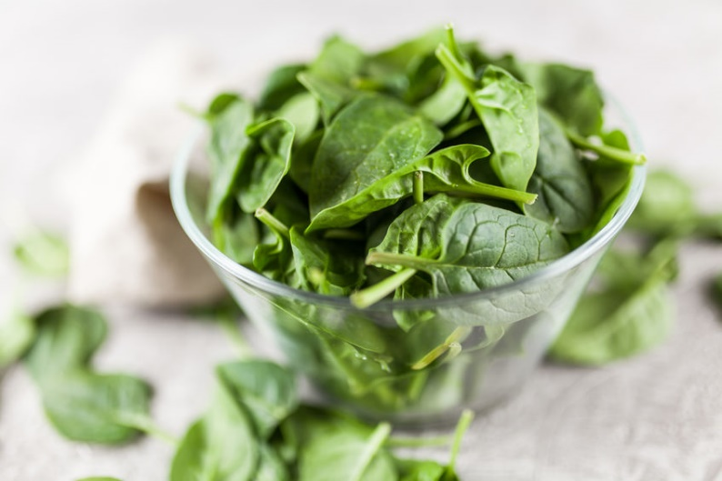  1 cup of boiled, drained spinach contains 245 mg of highly bioavailable Calcium without the excess saturated fat of dairy or the energy content of dairy. This is around 25% of your calcium needs for the day just in this one cup. Other good sources are low oxalate kale, bok choy, broccoli.  Milk has 276 mg of Calcium in one cup, so this is not that much more.  This cup of spinach has in addition 157mg of Magnesium (39% of your daily need) and 839 mg of Potassium (25% of daily requirements), and this cup of spinach has only 173 KJ (41 calories). It has no saturated fat and 4.3 grams of fibre.  If we look at one cup of whole milk, 3.25% fat, you have 622 Kj of energy (149 Calories which is 3.6x the energy of the spinach) with no fibre and with a calcium level that is only just higher than a cup of cooked spinach at 276mg. The milk has 4.6 grams of saturated fat. (All figures from the USDA database)  With regard to Magnesium, a critical mineral for the production of ATP (the energy molecule), the synthesis of nucleic acid and protein, and indeed vital for the action of 100’s of enzymes, 1 cup of whole milk has 24 mg in contrast to the 157mg of Magnesium in a cup of spinach, i.e. 6.5x less Magnesium. Low magnesium intakes are common with Western diets (think 95% not getting their recommended serves of fruit and importantly Magnesium-rich green vegetables. Low Magnesium levels impair gastrointestinal Calcium absorption and retention³⁵.
Eggs | No |   - Eggs are another staple with Sunday breakfasts dominated by egg choices and many people consuming eggs almost daily.  - The composition of the egg yolk of a battery-bred hen fed Omega-6 rich grains is vastly different to a truly free-range hen eating a wide variety of insects, wild seeds and plant matter such as Purslane containing a high level of the Omega-3 Alpha-Linolenic Acid (ALA)  - Hens are omnivorous, not vegan in other words, they eat vegetable and animal matter such as worms and insects if they were genuinely free-range, and this dramatically changes the nature of the yolk.  - Professor Artemis Simopoulos, an expert on Omega-3 essential fatty acids, studied this and found that a supermarket egg contains 19 times more Omega-6 fats than Omega-3 in comparison to a Greek egg that would be found on, say, the island of Crete, the home of the Mediterranean Diet⁸.  - The Western diet is already extremely high in inflammatory Omega-6 intake, and eggs add even more Omega-6s to this already abnormal level.  - Inflammation drives the vast majority of severe illnesses in society, such as prediabetes, diabetes, heart and vascular disease, obesity, Alzheimer's Disease, many cancers.  Eggs, Strokes, Diabetes and Cardiovascular Risk & Prostate Cancer Risk  - From the Heart Foundation³⁸, there is a 69% increased risk of cardiovascular related risk in those with diabetes consuming 7 eggs a week.  - Cosuming more than 2 eggs a week increased the risk of Type-2 Diabetes Mellitus by a massive 68%  - A paper on the risk of meat and egg consumption stated “Men who consumed 2.5 or more eggs per week had an 81% increased risk of lethal prostate cancer compared with men who consumed less than 0.5 eggs per week --- among healthy men³⁹.”  - Prostate and breasts are very similar in terms of hormonal control and what is bad for one will inevitably be bad for the other.
Saturated Fat | Your body needs saturated fat, but humans can create saturated fat from carbohydrates, and these are similar to animal fats¹⁰. | - In the absence of dietary fats, your body can synthesise saturated fats needed for cell membranes and other uses. These saturated fats can be synthesised from carbohydrates¹⁰. So consuming saturated fat in our diets is excessive and unnecessary.  - What you need to do is replace saturated fats with ‘good’ fats like monounsaturated fats from Avocado, nuts, seeds and to ensure you are getting enough Omega-3’s including ALA (Alpha Linolenic Acid) a short-chain Omega-3 found richly in Flaxseed and Flaxseed Meal.  - Lipopolysaccharide (LPS) in the blood, also known as Endotoxaemia, may increase by 50% even after one fatty meal¹¹. LPS is highly inflammatory and toxic. You can see why eating large amounts of animal fat and highly fatty meals long term may cause devastating inflammatory effects on the body driving a plethora of dreadful diseases like dementia or cardiovascular disease as these are driven by inflammation.  - It is known that a high saturated intake can increase LPS organisms in the gut microbiome and predispose to abnormal species there as well.
  Meats | Dairy
   | 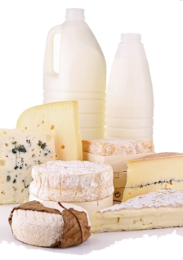
Fruit Juices | Not essential |   - Even one glass of orange juice can lead to an increase in central (aortic) blood pressure!  - This effect of Orange juice was studied at Australia’s Swinburne University, and the research showed that daily consumption of fruit juice was associated with significantly elevated central (aortic) blood pressure measurements but not the blood pressure measured at the arm¹².  This is why blood pressure at the doctor’s office doesn’t tell the whole story, and new devices are coming to a doctor’s consulting room in the not too distant future that will replace the BP measuring devices currently used in a doctor’s surgery and this device will measure both the brachial (arm) pressure as well as central arterial pressure (Aorta)  - Even small elevations in blood pressure can have disastrous outcomes long-term. Think aortic aneurysms.  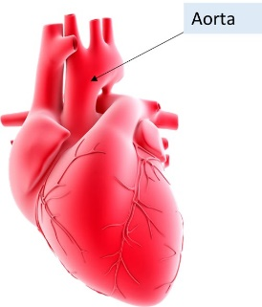  - Anyone with a dilated aortic root (near the heart) or in the abdominal aorta (aortic aneurysm) should avoid fruit juice as this is the large artery at risk of central arterial pressure elevations. A ruptured aortic aneurysm nearly always results in instant death!  - Another very sobering thought about the Fructose in fruit juice is a study that showed for every 350ml of fruit juice consumed; there was a vast 24% increased risk for all-cause mortality, i.e. the risk of all causes of death³⁷.  - Small amounts of certain fruit juices should be consumed and may be beneficial, such as Pomegranate rich in punicalagins and known to be protective of the heart and vascular system or Sour Cherries that are rich in anthocyanins and antioxidants or small amounts of Prune Juice that is rich in fibre and antioxidants. Around a 1/3 to ½ a glass a day of any of these will benefit the body as a whole due to the micronutrients and Vitamin-C provided.
Trans Fats | Toxic and avoid |   - Trans fats are a cardiovascular risk factor irrespective of other energy sources being consumed – it is an independent risk factor!  - Trans fats increase the bad LDL fat and decrease the good HDL component  - The way fat is processed in creating a processed food item adds trans fats to fried foods, baked foods like cakes, buns, cookies, pastries or deep-fried foods like chicken or chips
Vegetable Oils | No | - Such as Sunflower, Safflower, Soy, Canola oils due to their highly inflammatory Omega-6 levels  - The higher the intake of Omega-6’s, the greater the risk of coronary artery disease (CAD)⁹.
Processed Meats | Absolutely not necessary  IT MAY BE VERY DANGEROUS EVEN AT LOW INTAKES | - You may be surprised to know that processed meats are classified as Group 1 Carcinogens by the World Health Organisation (WHO), and this means strong evidence that this type of food causes cancer!  - Other compounds in this Group 1 Carcinogen list include - Asbestos, Arsenic, Benzene, Radioactive compounds and a large number of other dangerous chemicals.  - So you can see, that processed meats are among a very large group of highly toxic compounds that may trigger off cancer.  - N-Nitroso chemicals (NNO) are formed in the gut by the Nitrite and Nitrate chemicals used in the creation of processed meats that can lead to bowel cancer.  - Processed meats include salami, Bologna, Pepperoni, Pastrami, hot dogs, sausages, cured bacon, ham, cured meat, smoked meat, salted meat, corned beef, beef jerky, canned meat, Spam.  - So can you eat this once a week with your eggs and a glass of orange juice on a Sunday? Well, there is no lower threshold of processed meats that you can consume as even small quantities have the potential to act on your DNA trigger off chemically-induced mutations and cancer.  - Also, imagine that Sunday breakfast with the high Omega-6 intake with eggs and all that Fructose in a glass of orange juice raising your central arterial pressure. Then imagine the metabolic impact on your body with a stack of pancakes full of blood-glucose elevating carbohydrates, smothered in more glucose elevating Maple syrup, and why not add some triglyceride elevating cream or ice cream to this toxic mix.  - Each meal has the potential to cause damage, and this is cumulative over your lifetime, so you need to consider the impact that every meal can have. Every Meal Matters (EMM), and this is where meal composition is vital. This EMM approach is how Activ8Health meals are constructed.
  Processed Meats | Bacon
   | 
Red Meat  Beef, Lamb, Pork | Not essential  However many micronutrients will need to be supplemented such as Zinc, Vitamin-B12, Iron if animal meat is completely avoided. |   - Beef, lamb and pork are red meats classified as Group 2A carcinogens by the World Health Organisation (WHO). The items in this group mean that, in all probability, these foods cause cancer!  - When Haem or Heme, a compound in the blood that carries oxygen in red blood cells, is degraded in the bowel, the same compounds N-nitroso (NNO)chemicals are created in the bowel when meat is digested.  - This knowledge is mainstream scientific knowledge that cannot be argued – it is what it is! And yet, why isn’t this knowledge in every public health campaign?
Sweets, Simple Sugars (refined carbohydrates) | Absolutely not essential |   - There seems to be a total disregard for the impact sugar has on the body, but times have changed, and concerns are being voiced.  - Sugar powerfully raises blood glucose levels soon after consumption. This sugar will strongly stimulate the beta cells in the pancreas to produce high insulin levels, which, in turn, increases IgF-1, a highly anabolic molecule.  - Both high insulin and IgF-1 levels are strongly associated with cancer^{14,15,16}. Thus, there is an abundance of research to show that people with diabetes have a much higher risk of cancer and Insulin/IgF-1 will have an important role in this cancer generation.  - Sugar is a 50:50 mix of Glucose and Fructose, so you not only get the damaging effect of glucose, but you also get the highly damaging effect of Fructose.  - Anything that stimulates a struggling pancreas to produce more and more insulin will put that pancreas at risk, in particular with those who have prediabetes (insulin resistance) or diabetes in a similar way to the statement about dairy above.  - Fructose is 10-times more glycating than glucose, where glycation is the damage of proteins and tissues caused by sugar attaching to protein molecules and cross-linking them to distort them or impair their function¹⁷. This glycation effect may damage collagen or elastin in your sking ageing you faster or basement membrane proteins in the kidney or proteins in the brain and this is why people with diabetes suffer so much damage to tissue proteins in the kidneys, eyes (retina and lens), and blood vessels leading to blockages and gangrene. This glycation effect leads to damage of organ systems like the liver and brain.  - If you add honey or Agave to cereals you are adding simple carbohydrates to more complex carbohydrates in the cereal, thus generating a significant carbohydrate load with marked elevations in blood glucose after eating (postprandial elevation), producing a ‘mini diabetic’ event with each such meal having a cumulative effect over your lifetime.
   | 
  Honey ~50% Fructose | Agave Syrup ~75% Fructose
Carbs | Better carbs exist |   - A carb poured out of a box is never a good idea  - These are processed carbs, whether steel cut oats or grains crushed and squeezed into a biscuit  - Often cereals in a box will have sugar and salt and claim to have added nutrients. Nutrient-poor cereals do need added nutrients to fill in the deficiencies  - Unfortunately, people may pour honey on these carbs coming from a box. This action adds tremendously to simple sugar loading. Worst of all, the honey is 50% fructose, which we know from above, can increase central arterial blood pressure.  - Also, Fructose is 7 - 10 times (7x – 10x) more glycating than glucose (glycation is the damage to proteins by glucose binding and cross-linking), so Fructose has this glucose effect on proteins but many times worse³³.  - To make matters worse, people add dairy milk or yoghurt to their cereal and once again, we know from the information provided above that dairy has the Glycaemic Index (GI) insulin dissociation (GI-Insulin Dissociation) causing a significant spike in insulin levels after consuming dairy and this puts great pressure on the beta cells of the pancreas. Such pressure is adding a considerable risk to those 4 million Australians with insulin resistance (prediabetes) where their pancreas is already at risk of beta-cell burnout and the additional 1.5 million diabetics at significant risk from poor glucose metabolism after eating. It is estimated one new diabetic emerges every 5 minutes in Australia. So avoiding high carb, high glycaemic loads (GLs) makes absolute sense.  - Cereal grains are not essential, i.e. they do not have anything special that is needed by the body. However, suppose cereal grains show benefit in research. In that case, it is almost certainly the fibre component that is providing the benefit because grains are highly deficient in many nutrients. This fibre can be greatly surpassed by consuming vegetables mainly, and some fruit and other far better fibre-rich sources, as you will discover in this report.  - So the high glycaemic load from the starchy cereal pressed or shaped into something + the honey + dairy equals a very toxic load highly damaging to normal people and highly damaging to those who have prediabetes or diabetes putting them at great risk.  - This report offers many possibilities for low-carb meals  - Have dinner for breakfast – in other words, change your concept of breakfast from a nutrient-poor meal, which damages the body after eating to one that is highly nutritious and packed with carbs but the right ones like veggies and fruit plus some worthwhile protein like salmon or trout or the smaller oily fish or even a great smoothie with Essential Amino Acids (EAAs) where the EAAs can provide your body with all the amino acids it needs without the calories.

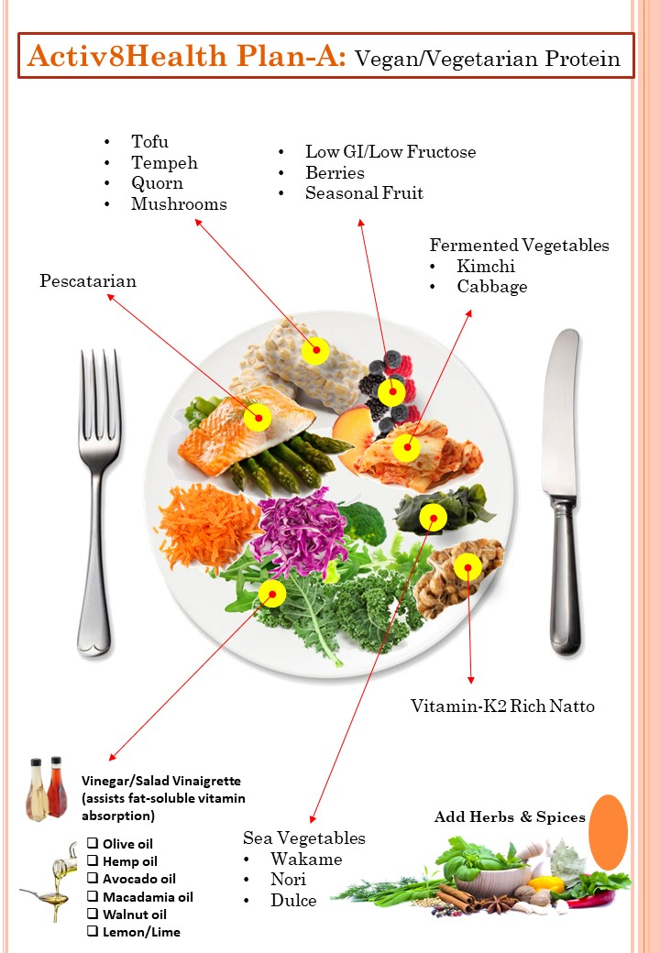

Protein intake: Vegan – Vegetarian - pescatarian
- Your total protein intake calculated at g/day
- You can divide this by 3 for grams per 3 meals a day or by 2 for two meals a day
- The main sources of protein are listed below
- Other protein sources such as vegetables, fruit, side foods need to be taken into consideration
Your result | Amount | Comment
Quorn (Vegan) | Choose an item.
Oily fish | Choose an item. | - 2 – 3 times a week
Oysters | Choose an item.
Tempeh (Vegan) | Choose an item.
Tofu (Vegan) | Choose an item.
Whitefish | Choose an item.

Protein content of certain foods

Item | Amount | Grams of protein
Comment: Fruit and Vegetables are rich in amino acids, and this needs to be considered with protein intake
Cabbage | 1 Cup | ~ 1 g
Fruit | Small Apple | 0.39 g
Fruit | Small Banana | 1.1 g
Mushrooms, white cooked | 1 Cup | 3.39 g
Nuts, mixed | ½ Cup | 16 g (Calorie dense so small amounts only and raw unsalted nuts)
Octopus/Molluscs | 100 g | 29 g
Oysters | 100 g | 9 g
Quorn | 100 g | 14.9 g
Tempeh | 1 Cup | 30 g
Tofu | 1 Cup | 10 g
Vegetables frozen, mixed | 1 Cup | 8 g
Spinach | 1 Cup | 2.34 g
Thus if we have around 10 cups of dark green leafy vegetables per day, that will amount to 23.4 grams of protein. In essence, we should all be aiming for the equivalent of 8 – 10 cups of vegetables per day but juicing may be a way of getting the phytochemicals required without eating whole vegetables.

vegetables (Non-starchy): at least ½ your plate
 |  | Comment
Comment
GREENS | CRUCIFEROUS | Sea Vegetables | Allium
Bok Choy | Cabbage | Nori | Onion
Spinach | Cauliflower | Dulce | Shallots
Lettuce | Broccoli & Sprouts | Wakame
Kale | Watercress
Mustard Greens | Mustard Greens
Rocket | Kohlrabi
Silverbeet | Collard Greens
 | Radish
Marrow | Stem | Roots
Cucumber | Celery | Carrot (orange, purple) Raw
Zucchini | Asparagus | Radish

Low glycaemic index fruit
 |  | Comment
Comment: Try to have fruit with a meal rather than a snack
Berries | Fruit | Fruit | Fruit
Blackberries | Avocado (1/2) | Rockmelon (Cantaloupe) ½ cup | Cherries ½ Cup
Raspberries | Nectarines | Small Plum
Blueberries | Feijoas | Small Orange
Strawberries | Watermelon | Small Peach

nuts
Your result | Amount | Comment
Comment
Mixed Nuts | 1/3 cup or as directed | - Try to have raw nuts instead of roasted as heating can change the protein structure in nuts and make them more allergenic  - Raw activated nuts even better as these are soaked to allow enzymes to breakdown compounds that bind minerals allowing more of them to become bioavailable  - 1/3 of a cup can provide a large 7 grams of protein which needs to be considered in the protein intake calculation

Seeds
Your result | Level | Comment
Comment
Mixed Seeds, Pepitas (Pumpkin), Squash Seeds, Sesame (include black sesame seeds) | 1/5th of a cup | - This can also provide 7 grams of protein and needs to be taken into consideration in the daily intake

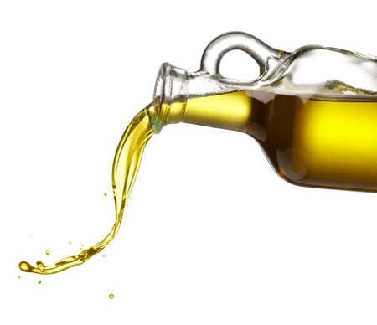
Oils to use
Oil | Uses | Benefits | Used for cooking? Comments
Avocado | - Salads | - High in monounsaturated fat  - High in Vitamin-E | - Yes  - Can be used for cooking  - The more refined oil has a higher smoke point
Canola |  | - High in monounsaturated Oleic Acid | Yes
Macadamia Oil | - Salads | - Around 60% of Oleic Acid  - High in Palmitoleic Acid  - Has valuable Alpha-Linolenic Acid (ALA) | - Palmitoleate has been shown to help improve insulin resistance²⁶.  - Alpha-Linolenic Acid (ALA) is a short-chain omega-3
Olive Oil  Extra Virgin | - Salads  - Cooking | - High in monounsaturated Oleic Acid  - Polyphenols | Yes – Olive and Canola oils are best for cooking.  Olive oil preferred, but both have monounsaturated Oleic Acid that is more stable than unsaturated (double-bond) fats
Peanut Oil   | Avoid this oil  Anyone with cardiovascular disease should stay away from this oil. | - Possible allergenic potential and lethal in some with anaphylaxis  - The concern with cardiovascular disease | - “Peanut oil is unexpectedly atherogenic for rats, rabbits, and primates²⁷.”  - This may be due to peanut lectin, but researchers who want to create vascular blockages in animal studies feed them peanut oil.
Sesame Oil, Black Cold Pressed | - Salads  - Stir-fries  - Asian cooking | - Rich in Sesamol an antioxidant  - Rich in Sesamin and Sesamolin sesame lignans that are anti-inflammatory  - Anthocyanins – the pigment that gives certain fruit, vegetables, seeds a dark or black colour is a powerful antioxidant | - Used for sautéing or light cooking


Personalised management from dietary analysis and test results

Finding | Specific issue | Action
Micronutrients |  | - Micronutrient sufficiency is critical to health and life  - Significant micronutrient deficiencies like iron or B12 can cause great harm with a B12 deficiency leading to a macrocytic anaemia or even spinal cord damage.  - Choline deficiency is common with significant adverse consequences  - As Harvard University states a Multivitamin/Mineral combination is an “insurance policy.”  - Irrespective of any controversy of the use of a multivitamin, many research articles are showing long-term benefit  - Often the research is geared to magic-bullet, quick pharmacological responses where efficacy is followed for weeks or months not decades  - Some single nutrient supplement may be needed if the problem is severe enough  - Discuss your needs with your practitioner
Macronutrients |  | - We need to get the macronutrient intake levels right  - Be guided by your practitioner  - High fat, high protein diets can be detrimental to the body and gut microbiome  - This diet is a high-carb diet but made up of vegetables predominantly where these are non-starchy, do not elevate glucose after eating and are high in fibre for a healthy gut microbiome
Omega-6 Intake |  | - Decrease Omega-6 rich oils as discussed in this report
Omega-3 Intake |  | - A high Omega-6 intake in conjunction with a low Omega-3 intake is a disaster for inflammatory processes in your body  - Many diseases have an inflammatory basis, such as prediabetes, diabetes, dementia, heart and vascular disease, and many cancers are driven by inflammation  - It is vital to establish a good Omega-6 to Omega-3 ration  - Your practitioner will guide you
Alpha-Linolenic Acid (ALA) |  | - Increase the use of Flaxseed Meal or seeds rather than the oil itself as this will provide a wealth of ALA + beneficial flaxseed lignans
Choline |  | - If low, a DHA Choline supplement can be used  - Choline is an essential nutrient that can cause both liver and muscle damage to adults that lack it  - Choline is critical to enable the switch from GABA, a neurotransmitter that is excitatory in foetal brain development, to an inhibitory neurotransmitter. This switch is essential to prevent childhood behavioural disorders and may also reduce the risk of Schizophrenia or other mental health disorders^{21, 22}.
Gut Microbiome Analysis |  | 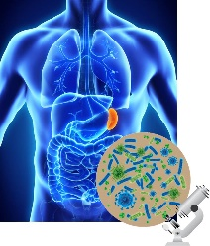  - Your practitioner will highlight any abnormalities (dysbiosis) in your gut microbiome and the necessary dietary (or medical) steps needed to correct these abnormalities discovered if you had the gut microbiome analysed.  - Medical help may be necessary

the activ8health antioxidant plate
This plate is all about eating with purpose, i.e. to mindfully add a tremendous amount of variety to your diet in just one sitting. Such a plate will increase fibre, antioxidant and phytochemical intake.
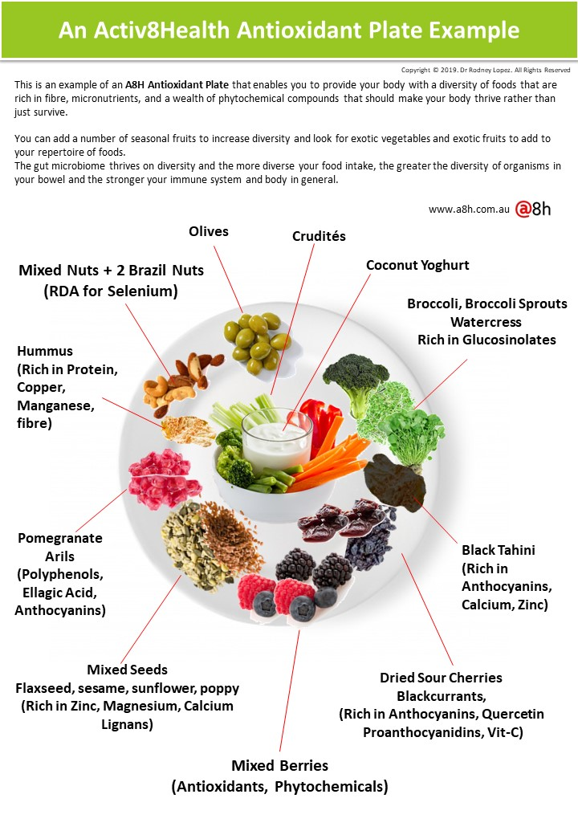
The ideal thing to do is to rotate items such as nuts or seeds so that on one day you may have one or two types of nuts or seeds and then swap these for other forms. The same applies to crudites consisting of raw or sliced vegetables. A suggested A8H Antioxidant Plate is shown.

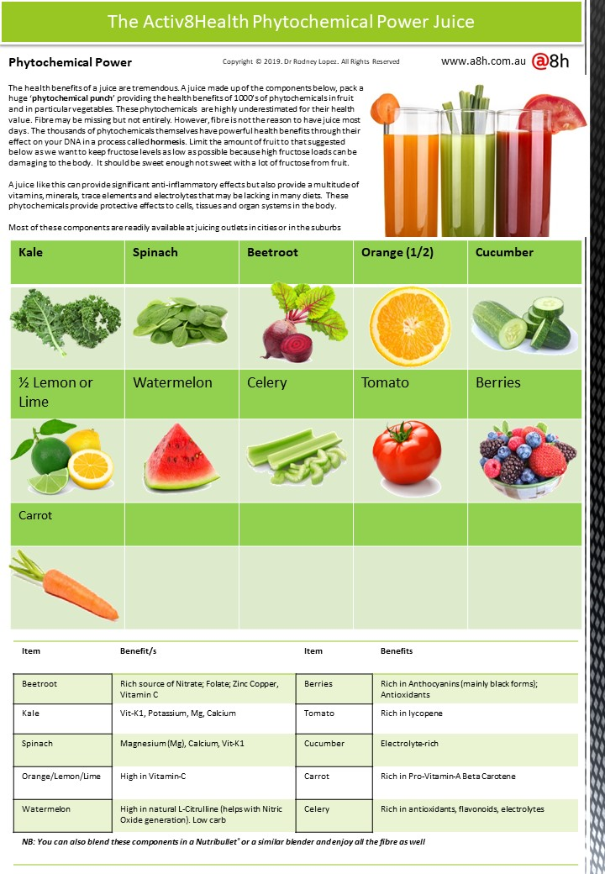
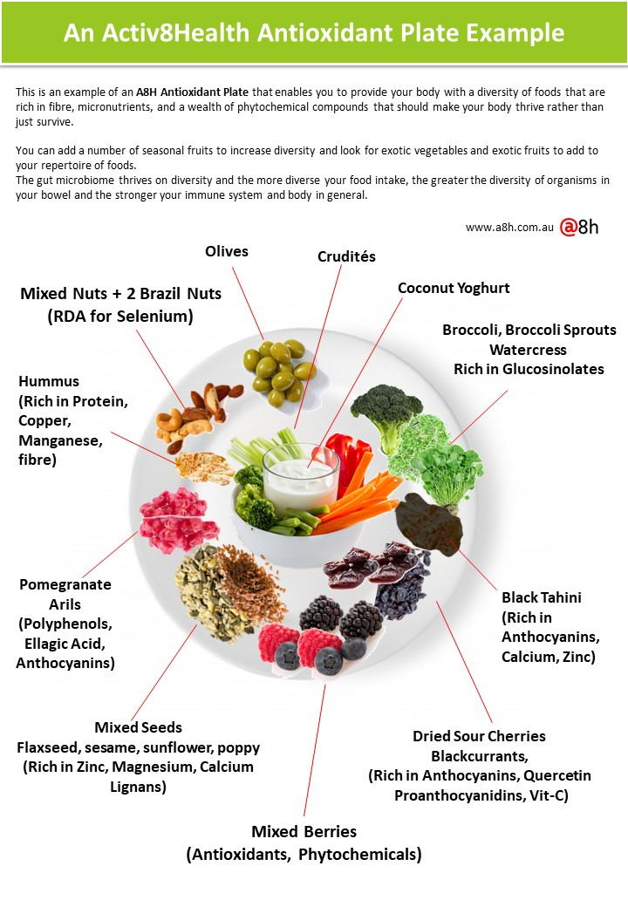

The activ8health fibre power bowl
The critical nature of fibre to your health is indisputable now. We know that dietary fibre (also known as prebiotic fibre) acts as food for the gut organisms (the Gut Microbiome). A healthy gut microbiome means a healthy body and immune system.
A NEW ACTIV8HEALTH MULTIFIBRE MIX IS NOW AVAILABLE. IT HAS 9 NOVEL FIBRES THAT CAN STIMULATE THE PRODUCTION OF BENEFICIAL SHORT CHAIN FATTY ACIDS (SCFAs) TO PROMOTE A HEALTHY GUT MICROBIOME. PLEASE DISCUSS THIS WITH YOUR PRACTITIONER.
What is sadly lacking in Western diets is that fibre intake is extremely poor, putting you at risk of many cancers, including bowel cancer and other chronic bowel conditions. Modern diets lack the diversity of fibres needed by the body, and these include pectin, soluble and insoluble fibre, mucilage, gums and cellulose and the roughage of plant stems.
This bowl aims to provide that diversity of fibre intake and once again as with the antioxidant plate; you can rotate these fibres having some on one day and then others the next. Rotating foods is an important principle in nutrition.
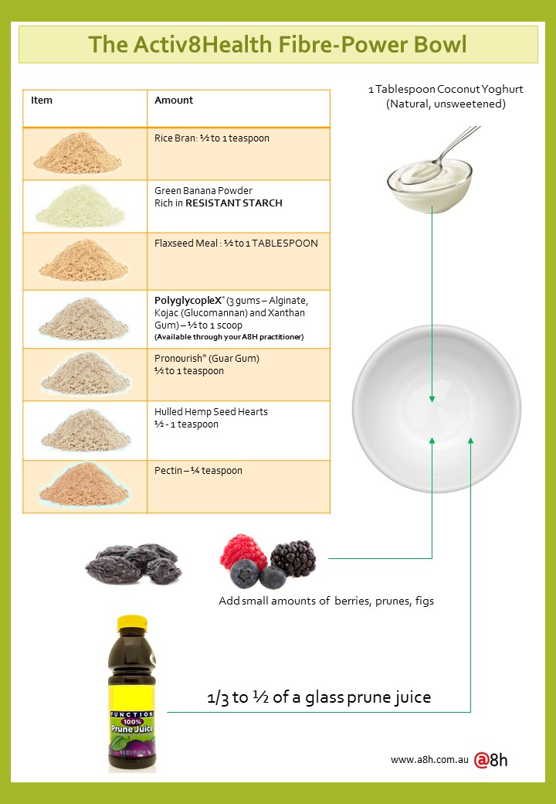


Low-Carb konjac carb substitute Options
Konjac, a Japanese root vegetable is one rich in gluten-free (GF) soluble fibre called Glucomannan (pictured). Fibres are prebiotics, and so your gut microbiome thrives on prebiotic foods. A high fibre diet is wonderful for gut health and indeed, the health of your whole body and immunity.
The benefits are vast from controlling blood glucose elevations to improved mineral absorption and gut health and can assist weight loss by making you feel fuller and improving the gut microbiome known to affect obesity if unfavourable organisms are present.
You can use this wonderful fibre in many ways shown below to provide a low-carb substitute for pasta, lasagna, rice
Konjac Product
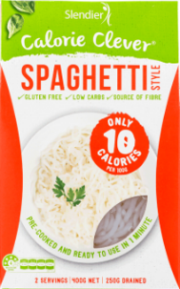 | 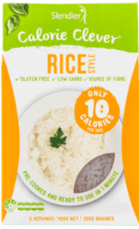 | 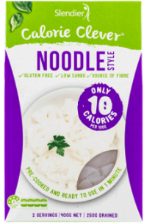 | 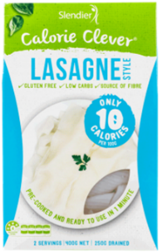 | 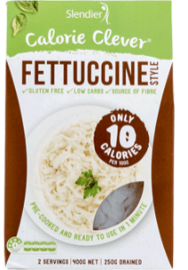 | 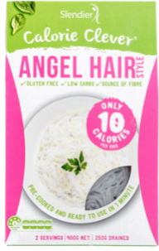
- Always start with a small amount to enable your body to get used to a higher fibre intake, for example, a quarter of a cup and adjust if you are experiencing abdominal bloating or discomfort.
- You can always mix these items with the real thing such as real Basmati or Black Rice or real pasta (wholegrain) to ease your way into a Plan-A low-starchy carb diet (remember, veggies are carbs but of the low Glycaemic Index and low-carb varieties.
- All of these products are Gluten-Free (GF) options

Activ8Health Plan-A Meal Ideas
It is important not to be too strict on yourself; otherwise, diets will not be sustainable. What follows are meal ideas and if you need to use pasta or rice, then do so and gradually add Konjac substitutes in mixed amounts or by itself to decrease the glycaemic load.
Making this a gradual process will mean you will most likely succeed with the fundamental basis of this diet.
Please re-imagine breakfasts from something coming out of a box depleted in nutrients and have real food absolutely rich in micronutrients, phytochemicals, fibre and antioxidants.
Sticking to low-carb options means less of a glycaemic (glucose) impact on the body after the meal and less of a stress to your pancreatic beta cells that have to produce insulin. Protein itself also demands a lot of insulin from the pancreas and there are very good reasons to have amounts of protein at lower amounts under 65 years of age and larger amounts if you are over 65. These protein amounts should be calculated by your practitioner
Meal | Comment | Companion/s
Breakfast Ideas: DON’T GET BREAKFAST OUT OF A BOX!
 | Vegetable & Fruit Blend (Smoothie)  - Whole low fructose fruit along with whole vegetables like Kale, Spinach, Cucumber, Carrot, Beetroot,  - This smoothie is a fibre-rich Plan-A meal in itself  - Add Essential Amino Acids (EAAs + L-Citrulline) Blend where 6 scoops of this blend will provide 3 grams of L-Leucine that has the anabolic power of a whole meal³¹. |   - The Essential Amino Acid Blends are designed to provide you with 3 grams of L-Leucine which provides the anabolic equivalent of a whole meal approximately 20 grams of whole protein.  - Citrulline enables you to produce Nitric Oxide critical to vascular health  - PolyGlycoplex Gums (see below) can also be blended adding more soluble fibre to your diet and these gums can lower the glycaemic (glucose) impact of your smoothie or meal
Breakfast Burrito   | - Use a rice paper or low-carb wrap  - Avocado  - A variety of multicoloured vegetables  - A Mexican-styled Salsa that will provide taste and is rich in tomato (lycopene)  A Naked Burrito  - All the ingredients in a bowl without the wrap | For those needing some starchy carbs due to increased exercise activity can always add some meaningful carbs such as Chickpeas, Black Beans, Lentils, Black Rice
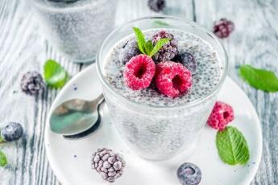 | Chia Muesli (Super Fibre Breakfast)  - Soak Chia seeds in the fridge overnight (1 Tablespoon) in Unsweetened Almond, other nut milk or Coconut milk or better still, zero-calorie water.  - In the morning, you can add more unsweetened low-cal milk to the soaked seeds to the consistency you prefer, or instead of the nut milk, you can add Prune Juice which is rich in soluble fibre and antioxidants  - Add 1 Tablespoon of Flaxseed Meal  - Add ½ teaspoon of Sunflower Lecithin (non-solvent extracted)  - Add fresh or frozen berries  - Add coconut chips, flakes  - A small amount of anthocyanin-rich (black antioxidant phytochemicals) in Blackcurrants can be added thought to be beneficial for the hippocampus and memory³⁴.  - Add blueberries, raspberries (organic) and avoid strawberries unless organic.  - Adding some PGX, soluble fibres can  Important:  Portion size will determine the amount of calories you take in. Keep the portion size small | - Adding six scoops of the EAA Sports with Citrulline Malate will provide you with the anabolic power of a whole meal without the calories or fats, carbs or animal protein  - The Citrulline will increase nitric oxide (NO) production for cardiovascular health  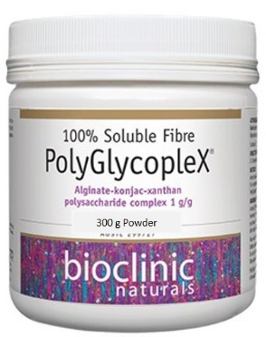  - Initially, half a scoop of the PolyGlycoplex in the Chia Muesli in the morning for adults and gradually increase  - This provides important gums for bowel health (Alginate, Konjac, Xanthan)  - Improve your gut microbiome to improve your immune system
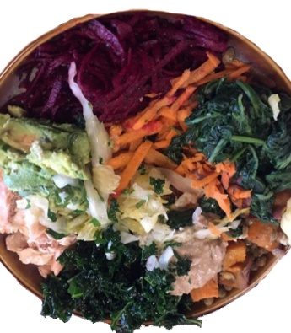 | The Rainbow Plate  Nothing out of a box will match the phytochemical or fibre power of this meal.  - This could easily become breakfast, lunch or dinner  - Shredded carrot orange or purple, cabbage or fermented vegetables, avocado, shredded kale, hummus, sweet potato or pumpkin, a small amount of lentils or chickpeas (1/4 Cup)  - Animal protein could include salmon, trout, shredded mackerel, herring, anchovies  - Vegetarian protein could include Tofu, Quorn, Tempeh  Add nuts, seeds such as black sesame
Breakfast, Lunch or Dinner
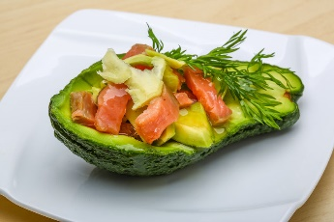 | Avocado Boat  - This is a quick, low-carb, highly nutritious meal that is perfect any time of day.  - This absolutely beats hands-down any breakfast or meal coming out of a box  - Have ½ an Avocado and stuff the centre with salmon or other oily fish as these are rich in Omega-3 Essential Fatty Acids. Avoid Tuna, Shark, Swordfish and use Mackerel, Herring, Anchovies, Salmon, Trout, Sardines  - You can also use chicken or turkey mince but limit red meat  - Quorn mince is a vegetarian choice or you can add Tofu  - Sprinkle with black sesame seeds for the anthocyanin content and natural Calcium  - Add herbs and spices to taste as these are also high in antioxidants
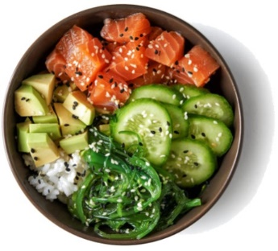 | Poke Bowl  - A Hawaiian dish that is simple and yet packed with diversity, phytochemicals, fibre and micronutrients  - Components could be raw (or cooked or smoked Salmon), Avocado pieces, Cucumber, Chukka Wakame other Veggies  - You can add a small amount (1 heaped Tablespoon) of Black, Brown, Red Rice or another carb except white rice which is nutrient-poor  - Many commercial outlets in food halls make up Poke Plates with slices of ginger, shallots, onion  - Soy or Tamari sauce can be used to taste  - Black Sesame Seeds can be sprinkled to add an Anthocyanin-rich, Calcium-Rich seed to the mix | - Reimagine breakfast instead of getting it out of a box  - Unfortunately, we are conditioned (trained through marketing) that the only form of breakfast in the West has to come out of a box  - These cereals are extremely poor choices because they are carb-rich and thus glucose-rich foods raising blood glucose levels very high after eating (see above)
 | Rice Paper Rolls  - These can be very low-carb and packed with diced vegetables from carrot, cucumber, celery, squash, cabbage, capsicum onion, shallots or any vegetable you fancy.  - These can be dipped in sauces such as Tamari or chilli  - It is important to remember that many cultures would never get their meals out of a box and would have something like this for breakfast adding diversity of food to their diet and strengthening their gut microbiomes through this diversity in food.
 | Low Carb Wraps; Keto Wraps  - You can search for low-carb wraps some of which may be gluten-free in your nearest supermarket  - Keto wrap recipes are freely available on the internet and made up of Flaxseed Meal and Coconut Flour  - These are tasty, low-carb wraps that can be filled with prawns or seafood, oily fish like Salmon, Trout, Chicken or Turkey  - Fill these with a variety of colourful veggies  - Avoid sugar-rich, salt-rich sauces | See Breakfast Burrito above
Lunch and Dinner Ideas
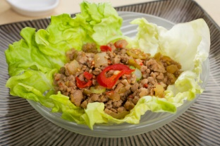 | San Choy Bow  - Mince or Quorn or another non-animal protein substitute rich with multicoloured vegetables, herbs and spices  - Low Carb but can use Konjac noodles or rice to bulk this up and add fibre-power
 | Seafood Paella  - Use Clever Rice or better still mix 50:50 with Konjac rice to decrease the carb load  - Add fish stock and seafood to your taste  - Try to include the small oily fish like Mackerel, Salmon, Trout, Anchovies, Herring as these are low in environmental contaminants and high in Omega-3’s
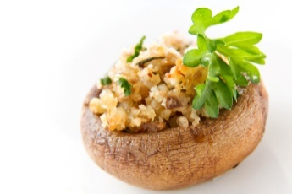 | Stuffed large mushrooms  - Like the San Choy Bow very low in carb but high in fibre and micronutrients  - Mushrooms have been shown in many trials to have health benefits e.g decreasing the risk of breast cancer³². | Remember to use Konjac rice in the mix
 | Wok Stir Fry  - An excellent low heat way of cooking multicoloured vegetables and animal or vegetarian meat substitutes  - Add a little bit of sesame oil for that wonderful Asian food taste | The Konjac Angel Hair noodles would make a good addition to this dish  Add black sesame seeds for the anthocyanin and calcium content and other nuts and seeds
 | Cauliflower Mash  - Low carb potato mash substitute  - Can be used with many other recipes such as Shepherd’s Pie  - You may mix in a small amount of pumpkin or orange sweet potato mash for the provitamin-A carotenoids  - Add a small amount of a good oil as the oil helps you absorb fat-soluble vitamins (A, D, E, K)
 | Shepherd’s Pie  - The use of animal mince or vegetarian substitutes such as Quorn  - Instead of mashed potato, use cauliflower mash  - Use dairy-free cheeses even Vegan Mozarrella or nut-based cheese for the surface | You can add a host of vegetables and even Konjac rice to this dish
 | Spaghetti Squash  - This oval vegetable belongs to the squash family  - After cooking, you can fork out long strands from the core which looks like spaghetti  - Use this like you would any other pasta for a very low-carb option  - The orange coloured flesh is rich in beta carotene | Add a little bit of Avocado oil or Macadamia or Olive oil to help absorb the oil-soluble beta carotene  Adding a small amount of oil to food and salads will help increase the absorption of fat-soluble vitamins – A, D, E, K and provitamin-A carotenoids
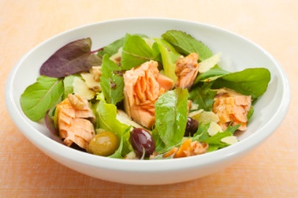 | Salmon or Trout Salad  - An excellent low-carb, high Omega-3 option  - Add some oil and lemon juice | Add complexity and diversity by sprinkling black sesame seeds for their rich anthocyanin and calcium content  Add pine nuts or walnuts or other nuts  Use seasonal vegetables and a diverse range of vegetables as this diversity in food is critical for a healthy diverse gut microbiome.
 | Seafood Noodle Stirfry  - The Konjac Angel Hair Noodles will be ideal for this dish  - Add some Sesame Seed Oil  - Add black sesame seeds for their anthocyanin (antioxidant) and calcium levels
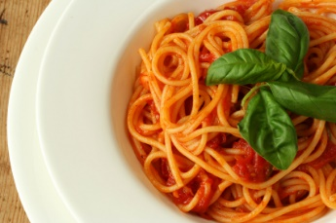 | Spaghetti Bolognese  - Use the Konjac pasta or mix 50:50 with real pasta  - Add a tomato-rich sauce full herbs, spices and blended diverse multicoloured vegetables | Use triple concentrate tomato paste for a lycopene-rich sauce  You can use meat or meat substitutes but keeping the practitioner guided protein levels to that calculated for you personally
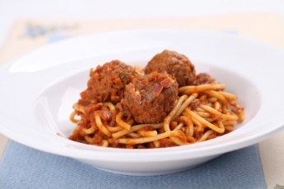 | Spaghetti & Meatballs  Using meat, meat substitutes such as nutmeat or Quorn, you can use a sauce rich in vegetables and tomatoes as above
 | Konjac Lasagne  - This is a low-carb version of lasagne  - Use the recommendations for meat or meat substitutes as above
 | Konjac Noodle Laksa  - This is a wonderfully rich Asian dish that can easily be made with Konjac noodles and in particular the Konjac Angel Hair Noodles  - Please add diversity in foods  consumed by adding a range of fresh herbs like Coriander or Parsley | A small amount of Sesame Oil will add that lovely Asian flavour
 | Zucchini Noodles  - You can make these noodles quickly and easily using a noodle maker like the one opposite  - Use these very low-carb, high-fibre noodles the same way you would use pasta and add vegetable and protein sauces to these noodles | 
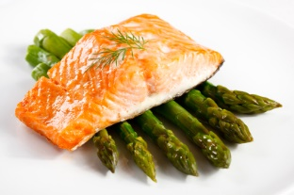 | Salmon Steak on Asparagus (or salad)  - Wild Salmon if you can get it will be higher in Omega-3’s and Astaxanthin
 | Adding Seaweed Flakes  - Diets around the world lack iodine except for cultures where a lot of seaweed and or seafood is eaten  - Significantly low iodine intakes are well documented in many Western countries including Australia  - Iodine is critical for thyroid health and the health of a growing foetal brain in pregnancy  - Seaweed is a rich source of not only iodine but minerals and trace elements critical for a healthy body | - Always make sure the seaweed packaged is ORGANIC as seaweed can accumulate many toxic metals if grown in polluted waters  - Apart from Nori, you can get Wakame and Dulce a red form of seaweed – try to get all 3 forms and vary their use day-to-day
 | Chuka Wakame  - This is a wonderful tasting wakame seaweed that is moist and easily added to salads or laksa’s or stir-fries | - Many places offering Poke plates or sushi will have this for sale or even Asian grocery shops
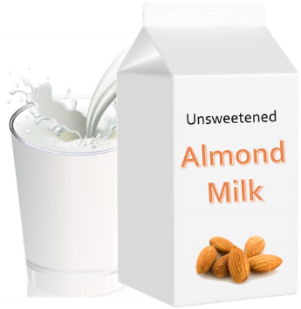 | Nut Milk  - A great dairy-free option  - Many nut milks are fortified with Calcium  - However, ensure these are Unsweetened as some may have a high kilojoule level

Supplements that may be of benefit
Item | Comment
PGX Soluble Fibre | - Discuss this with your practitioner  - It has been shown to decrease after-eating glucose levels and increase fullness (satiety) in Australian Universities such as Curtin, Flinders and Sydney University^{18,19}.  - For those wanting to control their waist and visceral fat, soluble fibres may be a worthwhile strategy where the capsule/s can be used with eating to modify the after-eating metabolic effects of food through fibre supplementation²⁰.  - Fibres, in general, are prebiotics and act as food for the gut microbiota  - The capsules are excellent for when you are out and about having lunch or dinner. The capsules are easy enough to carry around in a pill holder and kept in your pocket to have with meals.
Multivitamin, Mineral Supplement | - Discuss this with your practitioner  - Supplementation should be seen in the context of worsening food supply systems and nutrient loss between paddock to plate, poor and worsening soils worldwide, high-yield cultivars with diminished nutrient values, personal genetic mutations, personal lifestyle factors, personal ill-health and micronutrient depleting medications; all these conspire against optimal micronutrient sufficiency.  - It is wishful thinking that an optimal diet can account for all the micronutrients needed in Western societies that are reaching critical obesity levels due to poor dietary intakes (overfed and yet undernourished), and where 95% of individuals have nowhere near the fruit and in particular vegetable intakes necessary for good health.  - Fill in the gaps in nutrition to ensure the Triage Mechanism does not kick in where vital organs like the heart, brain, kidneys rob less vital organs (muscle, bone, ligaments, tendons) of nutrients to ensure you survive but in a weakened state.
Omega-3’s + Choline  Strongly consider this if you are planning a pregnancy or before brain development in pregnancy. The brain and spinal cord begin to form from week 6, but the baby’s brain grows rapidly from week 27 to 30. So start the Eagle DHA + Choline complex from as early on in pregnancy as possible and, better still, before falling pregnant. DHA has been shown to significantly decrease premature birth, a huge benefit in a Cochrane Collaboration finding   | - A supplement does exist where both Omega-3’s and Choline can be supplemented at one time.  - Both of these components are vital to humans  - Choline is an essential compound that is highly protective of the liver and muscle, and Choline should be regarded as a must in anyone consuming alcohol regularly.  - Non-Alcoholic Fatty Liver Disease (NALFD) is reaching epidemic proportions in line with the Obesity and Diabetes epidemic and Choline a very inexpensive supplement.  - Omega-3’s are vital for the brain and cell membranes and to dampen down inflammation.  - In the postmenopausal state with decreasing oestrogen levels, a Choline deficiency may result in serious health problems, including liver disease and skeletal muscle loss.  - Professor Robert Freedman, a molecular Psychiatrist, has compelling evidence that Choline in the antenatal period and the period of a baby’s brain development can prevent many childhood behavioural disorders and Schizophrenia²¹.  - The consequences for both men and women are high where 80% will suffer liver or skeletal muscle damage in a choline-deficient state²². Postmenopausal women who have very low oestrogen levels need a higher dietary of Choline to avoid liver and skeletal muscle damage.  - There is a higher risk of fatty liver as Choline has a vital role in transporting lipids from the liver.
N-Acetyl Cysteine | - Discuss this with your practitioner  - We cannot avoid every toxic compound we encounter, from cosmetics to deodorants or perfumes or scents (phthalates), to pollution in the air from cars or industry or the petrol vapours we inhale at the bowser known to cause cancer. Toxic compounds also exist in your home (synthetic carpets, lounges or other furniture). Finally, let’s not forget the pesticides, herbicides or toxic contaminants like heavy metals in fish or animal fat or the plastic compounds that leach into food from cooking in plastic containers or processed foods.  - What we can do is ensure that we provide the body with all the nutrients it needs to ensure a vigorous endogenous antioxidant system from a Multivitamin/Mineral supplement and N-Acetyl Cysteine (NAC)  - N-Acetyl Cysteine (NAC) is not a plaything. It is used highly successfully in an Accident & Emergency Department to reverse paracetamol (acetaminophen) poisoning because, without NAC, the liver would disintegrate (acute liver failure), due to a lack of glutathione synthesis depleted by the overdose.  - NAC can act as an insurance policy to aid glutathione synthesis by providing a stable, pharmaceutical-grade form of Cysteine a Sulphur-containing amino acid that is a precursor for glutathione production.
Essential Amino Acid (EAA) Blend  For everyday use | - Activ8Health practitioners have access to pure, pharmaceutical-grade essential amino acids (EAAs) that can be used to provide the anabolic (protein synthesis) impact of whole protein but without the calories.  - This EAA blend naturally has all the Branched Chain Amino Acids (BCAAs)  - The EAAs won’t supply the micronutrients that whole animal protein can but Zinc, Vitamin-B12 or Iron is the same whether it comes from an animal protein source or a supplement.
Essential Amino Acid (EAA) Blend + Citrulline  Uses:  - Exercise  - Heart Disease  - Vascular Disease  - To maintain healthy blood vessel dilation  - Erectile Dysfunction (ED)  - In those with a risk for vascular disease such as those with prediabetes, diabetes | - This essential amino acid blend can provide all the amino acid power you need  - This EAA blend naturally has all the Branched Chain Amino Acids (BCAAs)  - In addition to all these essential amino acids, this particular blend has L-Citrulline in the form of Citrulline Malate  - Citrulline has an amazing capacity to act like a ‘masked’ L-Arginine in that it avoids the first-pass metabolism in the liver which almost completely metabolises the L-Arginine to Urea leaving little if any to form Nitric Oxide (NO)  - Nitric Oxide is a critical molecule in the cardiovascular system as it is involved in dilation of blood vessels to make them wider (vasodilation) to carry more oxygen and nutrients to tissues including the heart muscle and as a result, to decrease blood pressure. A huge benefit to those with heart problems, vascular disease, high blood pressure or erectile dysfunction (ED)  - In sport or exercise, Nitric Oxide provides an advantage in that this vasodilation increases the delivery of amino acids to exercised tissue to stimulate protein synthesis and build muscle.
L-Citrulline | - As discussed above as a Nitric Oxide generator that is superior to L-Arginine. L-Citrulline may be of benefit in erectile dysfunction.  - This can be purchased on its own

Intraday (periodic) fasting
Fasting is now an important strategy for weight loss, metabolic disorders like prediabetes or diabetes, to prevent cancer and for cognition (clarity of mind). Initial studies were from rats and mice, but more and more human studies are being carried out showing significant metabolic benefits. There is strong evidence for periodic fasting having a positive effect on hypertension, inflammation (high CRP), obesity, the metabolic syndrome (prediabetes), high triglyceride (blood fat) levels and fasting blood glucose.
According to Dr Valter Longo, a pioneer in fasting and health and quoted in the peer-reviewed online medical database Medscape²³ he stated: “…periodic fasting or fasting-mimicking diet ..only needs to be done for most people three to four times per year for five days.”
Our Activ8Health program through this diet will already help tremendously with health and metabolic control but what may be even more beneficial and relatively easy to do is simply to skip a meal twice a week either breakfast or dinner which will give you 18 hours of fasting with increasing ketone production from 12 hours.
As one paper states, “It is well known that in humans, even a single fasting interval (e.g., overnight) can reduce basal concentrations of metabolic biomarkers associated with chronic disease such as insulin and glucose²⁴.”
This benefit also ties in intermittent fasting with the body’s circadian rhythm of eating with limited intake at night beneficial for health. It is known that late-night eating can increase the risk of cardiometabolic risks, such as diabetes²⁵. Those individuals who like eating late dinners and consume carb-rich meals such as pizzas or both carbs and refined sugars such as pancakes smothered in Maple syrup and then slept on this will have blood glucose and triglycerides (blood fats) stay elevated for 6 hours or more while they sleep. What late eating means is that insulin receptors will become less responsive in the morning as your body interprets this late-night feast as ‘I have enough energy, and so I will shut off the insulin receptors and divert that glucose to fat stores’. This makes sense in terms of having a meal in the morning, i.e. breakfast. Any calories you consume then after a late-night meal will not be utilised for energy because as mentioned above, the insulin receptors are less responsive, and calories will thus be diverted to fat.
With this knowledge and as this research states, “Research in animals highlights the potential importance of synchronising intermittent fasting regimens with daily circadian rhythms²⁴.” It is now becoming more apparent that we need to take heed of our circadian rhythms of eating. While asleep, we do not need excess calories as organ systems are starting to die down and so we are working against our evolutionary design. Cutting out the evening meal (dinner) is shaping up to be an important strategy to maintain cardiovascular health and healthspan.
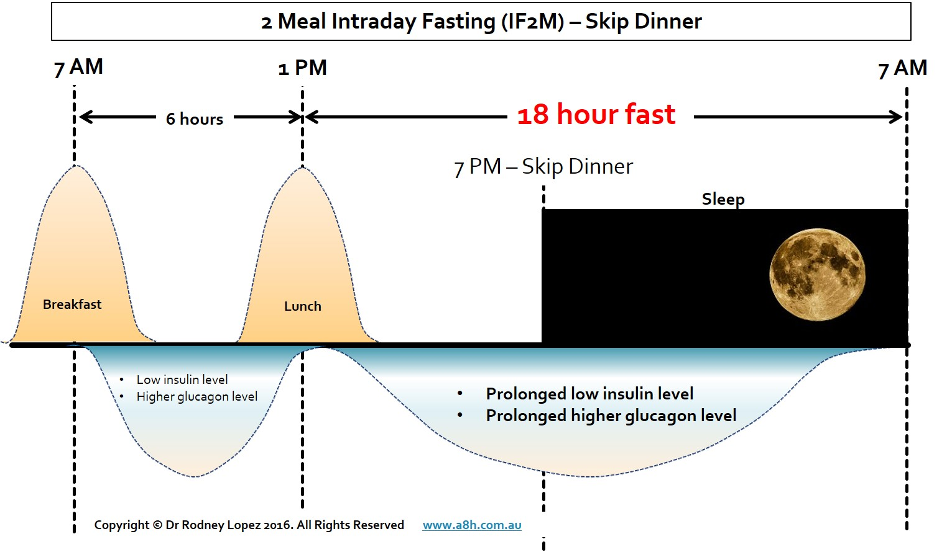

If we have lunch before 1 pm and then avoid dinner, we have 18 hours of fasting. You will wake up hungry with insulin receptors at heightened sensitivity. Having an Activ8Health Plan-A, low starchy carb diet like this diet proposed will mean you will not flood your body with glucose and your body will be far healthier and resistant to disease. You will have decreased that caloric pressure to constantly drive cell multiplication (a feast signal) causing obesity and can also drive cancer cells to multiply as they also need a lot of energy to survive.
If we did this nighttime fasting even twice a week, we would have 1,872 hours of fasting a year, which is a staggering cumulative 78 days of fasting in a year!
Intermittent fasting only works if we are not malnourished and if you meet your energy and protein needs. If this is something you wish to do, please discuss this with your Activ8Health Dietitian so that all of this can be calculated for you and you can be advised on how to maintain nutrient sufficiency while adopting a fasting (nutrient-limiting) strategy.

comments

Other comments:


Practitioner support packages
Support packages are available from 15 minutes to an hour or more if you need extra help. Please discuss your needs with your practitioner who can advise how long it will take to answer the queries you have and can then select the appropriate time packages and add it to your cart and email this to you for payment if you agree to this.

We wish you optimal health - from the Activ8Health team.

References
- Francis, G., et al. (1988). "Insulin-like growth factors 1 and 2 in bovine colostrum. Sequences and biological activities compared with those of a potent truncated form." Biochemical Journal 251(1): 95-103.
- Hoyt, G., et al. (2005). "Dissociation of the glycaemic and insulinaemic responses to whole and skimmed milk." British Journal of Nutrition 93(02): 175-177.
- Brand-Miller, J., et al. (2002). The New Glucose Revolution: The Glycemic Index Solution for Optimum Health, Hodder.
- Melnik, B. C., et al. (2011). "Over-stimulation of insulin/IGF-1 signaling by western diet may promote diseases of civilisation: lessons learnt from laron syndrome." Nutrition & Metabolism 8(1): 41.
- Renehan, A. G., et al. (2006). "Obesity and cancer risk: the role of the insulin-IGF axis." Trends in Endocrinology & Metabolism 17(8): 328-336.
- Anisimov, V. (2003). "Insulin/IGF-1 signaling pathway driving aging and cancer as a target for pharmacological intervention." Experimental gerontology 38(10): 1041-1049.
- Rea, P. A. and A. Y. Tien (2017). "Metformin: Out of Backwaters and into the Mainstream." American Scientist 105(2): 102.
- Simopoulos, A. P. and L. Sidossis (2000). "What is so special about the traditional diet of Greece." Mediterranean Diets. World Rev Nutr Diet 87: 24-42.
- DiNicolantonio, J. J. and J. H. O’Keefe (2018). "Omega-6 vegetable oils as a driver of coronary heart disease: the oxidised linoleic acid hypothesis." Open Heart 5(2): e000898.
- German, J. B. and C. J. Dillard (2004). "Saturated fats: what dietary intake?" The American journal of clinical nutrition 80(3): 550-559.
- Erridge, C., et al. (2007). "A high-fat meal induces low-grade endotoxemia: evidence of a novel mechanism of postprandial inflammation." The American journal of clinical nutrition 86(5): 1286-1292.
- Pase, M. P., et al. (2015). "Habitual intake of fruit juice predicts central blood pressure." Appetite 84: 68-72.
- Collin, L. J., et al. (2019). "Association of Sugary Beverage Consumption With Mortality Risk in US Adults: A Secondary Analysis of Data From the REGARDS Study." JAMA network open 2(5): e193121-e193121
- Anisimov, V. (2003). "Insulin/IGF-1 signaling pathway driving aging and cancer as a target for pharmacological intervention." Experimental gerontology 38(10): 1041-1049.
- Melnik, B. C., et al. (2011). "Over-stimulation of insulin/IGF-1 signaling by western diet may promote diseases of civilisation: lessons learnt from laron syndrome." Nutrition & Metabolism 8(1): 41.
- Sandhu, M. S., et al. (2002). "Insulin, insulin-like growth factor-I (IGF-I), IGF binding proteins, their biologic interactions, and colorectal cancer." Journal of the National Cancer Institute 94(13): 972-980.
- McPherson, J. D., et al. (1988). "Role of fructose in glycation and cross-linking of proteins." Biochemistry 27(6): 1901-1907.
- Solah, V., O’Mara-Wallace, B., Meng, X., Gahler, R., Kerr, D., James, A., Fenton, H., Johnson, S. and Wood, S., 2016. Consumption of the soluble dietary fibre complex PolyGlycopleX® reduces glycaemia and increases satiety of a standard meal postprandially. Nutrients, 8(5), p.268.
- Solah, V.A., Brand-Miller, J.C., Atkinson, F.S., Gahler, R.J., Kacinik, V., Lyon, M.R. and Wood, S., 2014. Dose-response effect of a novel functional fibre, PolyGlycopleX®, PGX®, on satiety. Appetite, 77, pp.74-78.
- Reimer, R.A., Yamaguchi, H., Eller, L.K., Lyon, M.R., Gahler, R.J., Kacinik, V., Juneja, P. and Wood, S., 2013. Changes in visceral adiposity and serum cholesterol with a novel viscous polysaccharide in Japanese adults with abdominal obesity. Obesity, 21(9), pp.E379-E387.
- Ross, R. G., et al. (2013). "Perinatal choline effects on neonatal pathophysiology related to later schizophrenia risk." American Journal of Psychiatry 170(3): 290-298.
- Fischer, L. M., et al. (2010). "Dietary choline requirements of women: effects of estrogen and genetic variation." The American journal of clinical nutrition 92(5): 1113-1119.
- Watson, J. (July 12, 2018). "Hungry for Health: Fasting's Health Benefits." from https://www.medscape.com/viewarticle/898953_1#.
- Patterson, R.E., Laughlin, G.A., LaCroix, A.Z., Hartman, S.J., Natarajan, L., Senger, C.M., Martínez, M.E., Villaseñor, A., Sears, D.D., Marinac, C.R. and Gallo, L.C., 2015. Intermittent fasting and human metabolic health. Journal of the Academy of Nutrition and Dietetics, 115(8), pp.1203-1212.
- St-Onge, M.P., et al. (2017). "Meal timing and frequency: implications for cardiovascular disease prevention: a scientific statement from the American Heart Association." Circulation 135(9): e96-e121.
- Olefsky, J. M. (2008). "Fat talks, liver and muscle listen." Cell 134(6): 914-916.
- Kritchevsky, D., et al. (1998). "Lectin may contribute to the atherogenicity of peanut oil." Lipids 33(8): 821-823.
- Billis, A. (1986). "Latent carcinoma and atypical lesions of prostate An autopsy study." Urology 28(4): 324-329.
- Bhathal, P., et al. (1985). "Frequency of benign and malignant breast lesions in 207 consecutive autopsies in Australian women." British journal of cancer 51(2): 271.
- Nielsen, M., et al. (1984). "Precancerous and cancerous breast lesions during lifetime and at autopsy. A study of 83 women." Cancer 54(4): 612-615.
- Norton, L. and G. J. Wilson (2009). "Optimal protein intake to maximise muscle protein synthesis." AgroFood industry hi-tech 20: 54-57.
- Li, J., Zou, L., Chen, W., Zhu, B., Shen, N., Ke, J., Lou, J., Song, R., Zhong, R. and Miao, X., 2014. Dietary mushroom intake may reduce the risk of breast cancer: evidence from a meta-analysis of observational studies. PloS one, 9(4), p.e93437.
- McPherson, J. D., et al. (1988). "Role of fructose in glycation and cross-linking of proteins." Biochemistry 27(6): 1901-1907.
- Pojer, E., et al. (2013). "The case for anthocyanin consumption to promote human health: a review." Comprehensive Reviews in Food Science and Food Safety 12(5): 483-508.
- Cordain, L., 1999. Cereal grains: humanity's double-edged sword. World review of nutrition and dietetics, 84, pp.19-19.
- Outwater, J.L., Nicholson, A. and Barnard, N., 1997. Dairy products and breast cancer: the IGF-I, estrogen, and bGH hypothesis. Medical hypotheses, 48(6), pp.453-461.
- Collin, L.J., Judd, S., Safford, M., Vaccarino, V. and Welsh, J.A., 2019. Association of sugary beverage consumption with mortality risk in US adults: a secondary analysis of data from the REGARDS study. JAMA network open, 2(5), pp.e193121-e193121.
- Heart Foundation.Eggs and cardiovascular health..Summary of Evidence NHFA: Melbourne (2019). Doi: https://www.heartfoundation.org.au/getmedia/c1f95635-f0cb-4d9f-8221-f08463e61975/Nutrition_Evidence_papers_-_Summary_EGGS_FINAL.pdf
- Richman, E.L., Kenfield, S.A., Stampfer, M.J., Giovannucci, E.L. and Chan, J.M., 2011. Egg, red meat, and poultry intake and risk of lethal prostate cancer in the prostate-specific antigen-era: incidence and survival. Cancer prevention research, 4(12), pp.2110-2121.

